GALGOTIAS COLLEGE OF ENGINEERING & TECHNOLOGY

Object Oriented Programming Lab
Subject Code: BMC252
Semester: II


Session: 2025-26

Submitted To: Submitted By:
Mr Md Shahajad Anshika Trivedi
AP, MCA Department Roll No: 2500970140031

Department of Computer Applications
Knowledge Park II, Greater Noida, Uttar Pradesh 201310

INDEX

S.N | Name of the Program | Date of Implementation | Date of Submission | Sign
1 | Write a program in Java to print Hello.
2 | Write a program in java to understand the difference between print () and println ()
3 | Write a program in Java with two classes create a object of first class and call into another class (having main method)
4 | Write a program in java to product of two numbers
5 | Write a program in java product of two numbers (Input by the user)
6 | Write a program in java to illustrate the concept of local, instance and static variable
7 | Write a program in java to implement implicit and explicit type casting
8 | Write a program in java to implement the various operators in java
9 | Write a program in Java for constructor overloading
10 | Write a program in Java for method overloading
11 | Write a program in Java for method overriding
12 | Write a program in java to show run time polymorphism (up casting)
13 | Write a program in java for access specifiers (all four)
14 | Write a program in java to implement the single dimension array
15 | Write a program in java to copy the elements from one array to another array
16 | Write a program in java to perform the addition and multiplication in 2-D array
17 | Write a program in Java for simple inheritance
18 | Write a program in java for Final keyword
19 | Write a program in java for super keyword
20 | Write a program in Java chaining constructor
21 | Write a program in Java for abstract method and abstract class
22 | Write a program in Java for interface
23 | Write a program in Java multiple inheritance
24 | Write a program in Java for Object Cloning (shallow and deep copy)
25 | Write a program in Java for Inner Classes (all types)
26 | Write a program in java to create the package (user defined package)
27 | Write a program in Java for exception handling by using try, catch and finally
28 | Write a program in Java for throw and throws Exception
29 | Write a program in Java to throw your own Exceptions
30 | Write a program in Java to reading and writing in file using byte stream
31 | Write a program in Java to reading and writing in file using character stream.
32 | Write a program in Java to reading and writing through console class.
33 | Write a program in Java how to create thread using Thread Class.
34 | Write a program in Java how to create thread using runnable interface.
35 | Write a program in Java to implement the multithreading.
36 | Write a program in Java to achieve synchronization in threads.
37 | Write a program in Java to implement the concept of Priorities in threads.
38 | Write a program in Java to illustrate the concept of Generic Programming
39 | Write a program in Java to illustrate the concept of event handling (using various event handlers)
40 | Create a simple student registration application using various swing components (like: JFrame, JButton, JLabel, text fields, text areas, check box and radio buttons).

Program No. 1

Objective: Write a program in Java to print Hello.

Code Implementation (Source Code):
public class Main {
public static void main(String[] args) {
System.out.println("Hello !!");
}
}
```

**Output:**
```
Hello, World!
Output Screen:

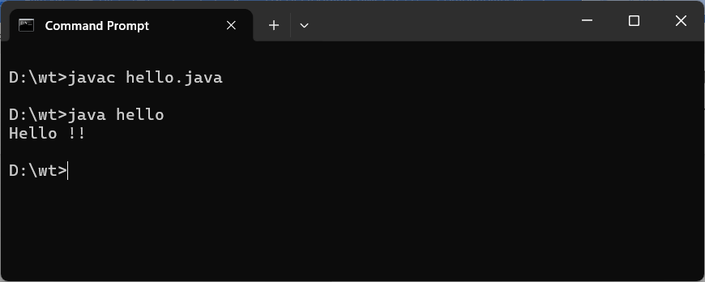

Program No. 2

Objective: Write a program in java to understand the difference between print () and println ().

Code Implementation (Source Code):
public class Que2{

public static void main(String [] args){

System.out.println("Welcome to Object oriented programming Lab");
System.out.println("Semester -2nd");
System.out.print(" Roll No-031“);

}
}
Output Screen:
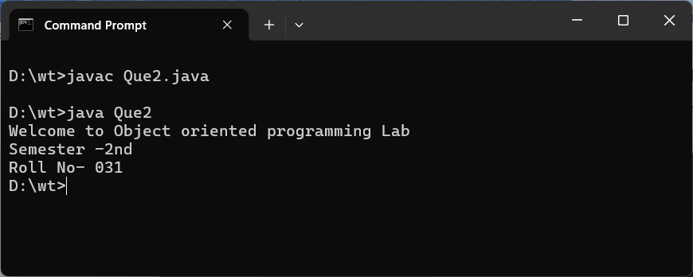

Program No. 3

Objective: Write a program in Java with two classes create a object of first class and call into another class (having main method).

Code Implementation (Source Code):
class First {
void display() {
System.out.println("Hello from First class!");
}
}

public class Main {
public static void main(String[] args) {
First obj = new First();
obj.display();
}
}

Output Screen:
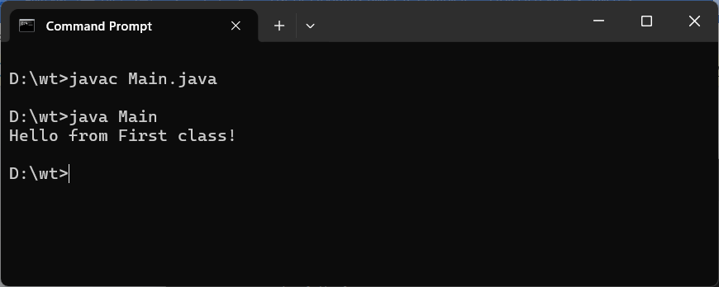
Program No. 4

Objective: Write a program in java to product of two numbers.

Code Implementation (Source Code):
public class Main {
public static void main(String[] args) {
int a = 5, b = 10;
int product = a * b;
System.out.println("Product = " + product);
}
}

Output Screen:
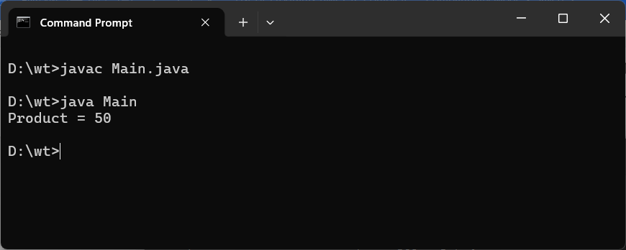

Program No. 5

Objective: Write a program in java product of two numbers (Input by the user).

Code Implementation (Source Code):
import java.util.Scanner;

public class Main {
public static void main(String[] args) {
Scanner sc = new Scanner(System.in);
System.out.print("Enter first number: ");
int a = sc.nextInt();
System.out.print("Enter second number: ");
int b = sc.nextInt();
System.out.println("Product = " + (a * b));
}
}

Output Screen:
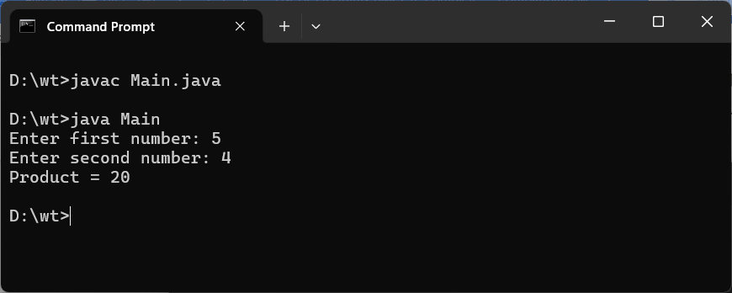

Program No. 6

Objective: Write a program in java to illustrate the concept of local, instance and static variable.

Code Implementation (Source Code):
public class Main {
int instanceVar = 10;
static int staticVar = 20;

void show() {
int localVar = 30;
System.out.println("Local: " + localVar);
System.out.println("Instance: " + instanceVar);
System.out.println("Static: " + staticVar);
}

public static void main(String[] args) {
Main obj = new Main();
obj.show();
}
}

Output Screen:
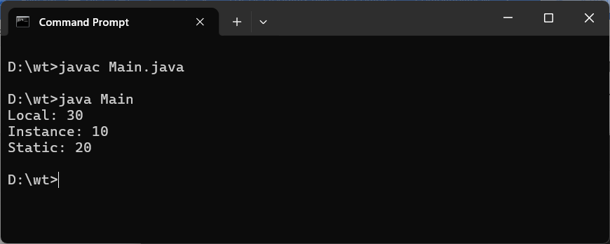
Program No. 7

Objective: Write a program in java to implement implicit and explicit type casting.

Code Implementation (Source Code):
public class Main {
public static void main(String[] args) {
int i = 100;
double d = i;
System.out.println("Implicit (int to double): " + d);

double x = 9.99;
int y = (int) x;
System.out.println("Explicit (double to int): " + y);
}
}

Output Screen:

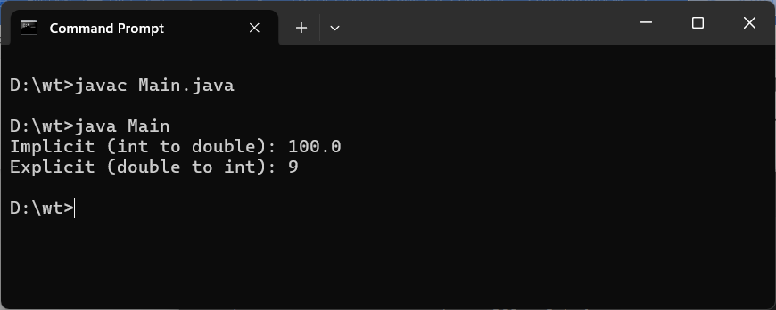

Program No. 8

Objective: Write a program in java to implement the various operators in java.

Code Implementation (Source Code):
public class Main {
public static void main(String[] args) {
int a = 10, b = 3;
System.out.println("Addition: " + (a + b));
System.out.println("Subtraction: " + (a - b));
System.out.println("Multiplication: " + (a * b));
System.out.println("Division: " + (a / b));
System.out.println("Modulus: " + (a % b));
System.out.println("a > b: " + (a > b));
System.out.println("a == b: " + (a == b));
}
}

Output Screen:
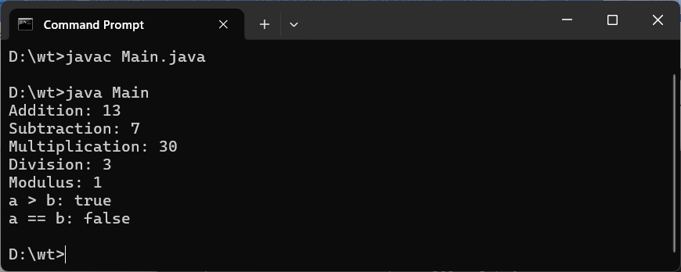

Program No. 9

Objective: Write a program in Java for constructor overloading.

Code Implementation (Source Code):
public class Main {
int a, b;
Main() {
a = 0; b = 0;
}
Main(int x) {
a = x;
}
Main(int x, int y) {
a = x; b = y;
}

void display() {
System.out.println("a = " + a + ", b = " + b);
}

public static void main(String[] args) {
new Main().display();
new Main(5).display();
new Main(5, 10).display();
}
}

Output Screen:
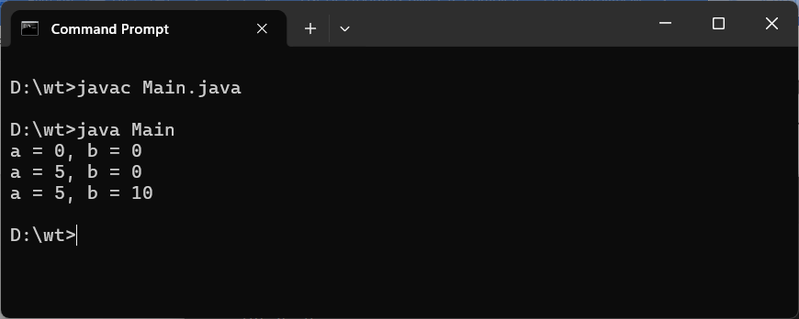
Program No. 10

Objective: Write a program in Java for method overloading.

Code Implementation (Source Code):
public class Q10 {
int add(int a, int b) {
return a + b;
}

double add(double a, double b) {
return a + b;
}

int add(int a, int b, int c) {
return a + b + c;
}

public static void main(String[] args) {
Q10 obj = new Q10();
System.out.println("Sum(int): " + obj.add(5, 10));
System.out.println("Sum(double): " + obj.add(2.5, 3.5));
System.out.println("Sum(3 ints): " + obj.add(1, 2, 3));
}
}

Output Screen:
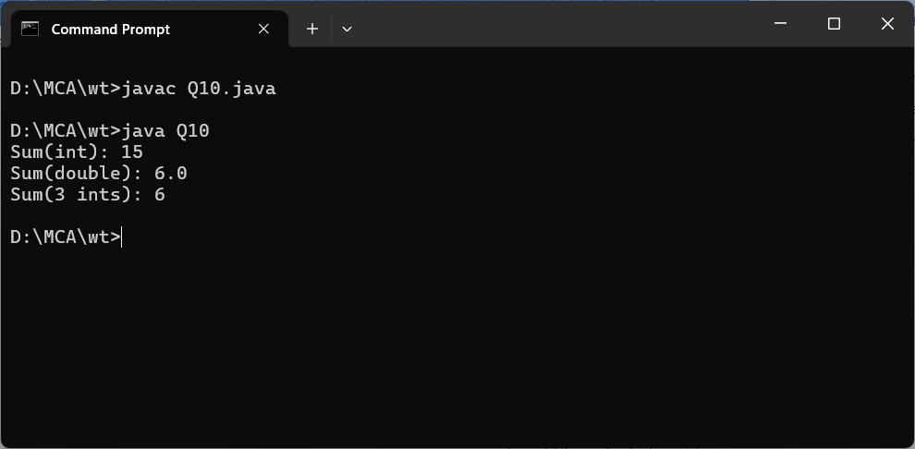

Program No. 11

Objective: Write a program in Java for method overriding.

Code Implementation (Source Code):
class Animal {
void sound() {
System.out.println("Animal makes a sound");
}
}
class Dog extends Animal {
@Override
void sound() {
System.out.println("Dog barks");
}
}
public class Q11 {
public static void main(String[] args) {
Animal a = new Dog();
a.sound();
}
}
Output Screen:
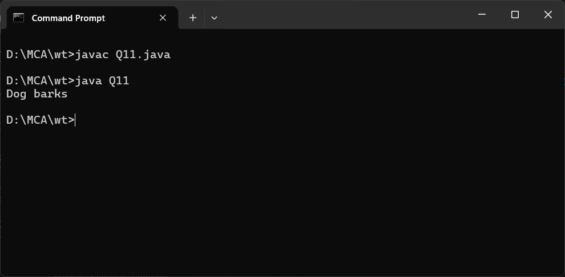
Program No. 12

Objective: Write a program in java to show run time polymorphism (up casting).

Code Implementation (Source Code):
class Shape {
void draw() {
System.out.println("Drawing Shape");
}
}

class Circle extends Shape {
void draw() {
System.out.println("Drawing Circle");
}
}

class Rectangle extends Shape {
void draw() {
System.out.println("Drawing Rectangle");
}
}

public class Q12 {
public static void main(String[] args) {
Shape s;
s = new Circle();
s.draw();
s = new Rectangle();
s.draw();
}
}

Output Screen:

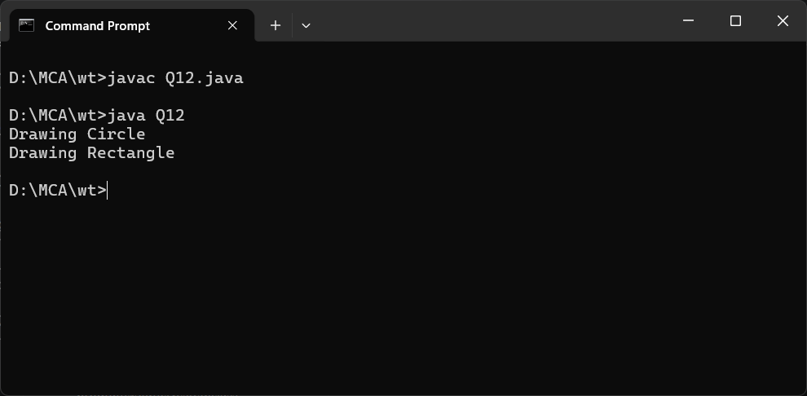
Program No. 13

Objective: Write a program in java for access specifiers (all four).

Code Implementation (Source Code):
public class Q13 {
public int pubVar = 1;
protected int protVar = 2;
int defaultVar = 3;
private int privVar = 4;

void show() {
System.out.println("Public: " + pubVar);
System.out.println("Protected: " + protVar);
System.out.println("Default: " + defaultVar);
System.out.println("Private: " + privVar);
}

public static void main(String[] args) {
Q13 obj = new Q13();
obj.show();
}
}

Output Screen:
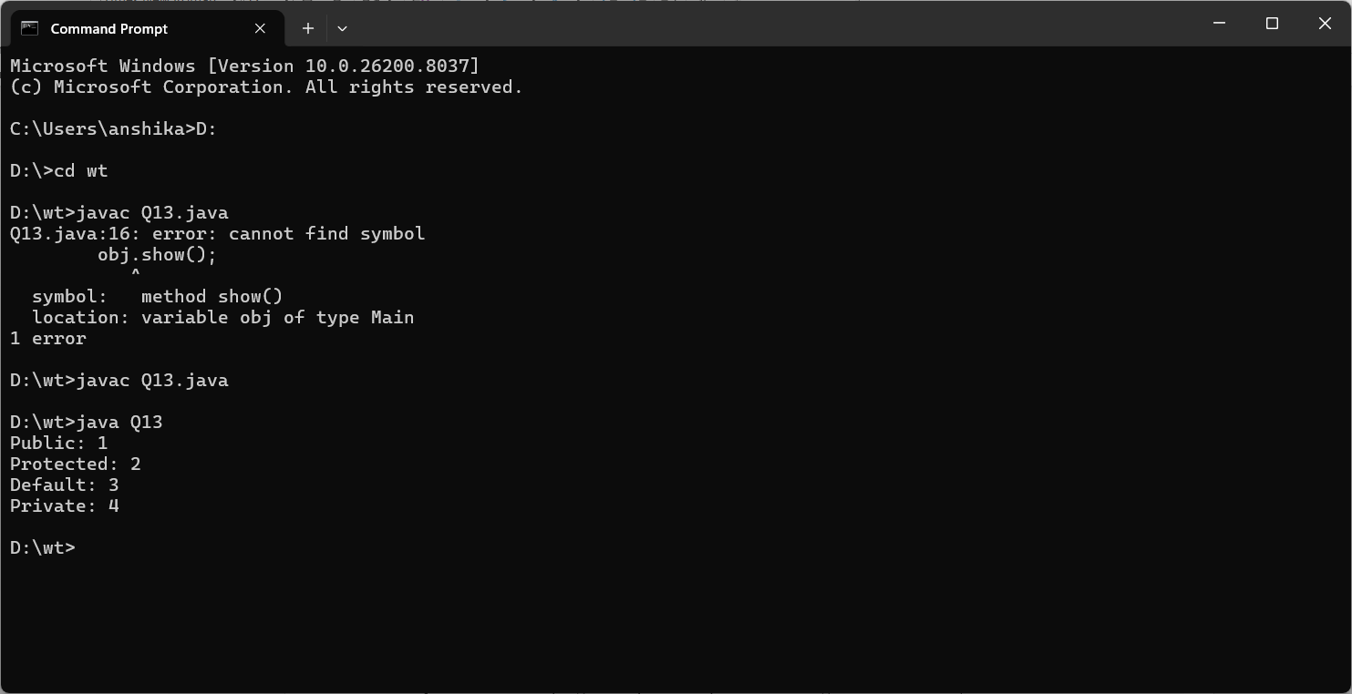

Program No. 14

Objective: Write a program in java to implement the single dimension array.

Code Implementation (Source Code):
public class sdimention {
public static void main(String[] args) {
int[] arr = {10, 20, 30, 40, 50};
System.out.println("Array elements:");
for (int i = 0; i < arr.length; i++) {
System.out.println("arr[" + i + "] = " + arr[i]);
}
}
}

Output Screen:
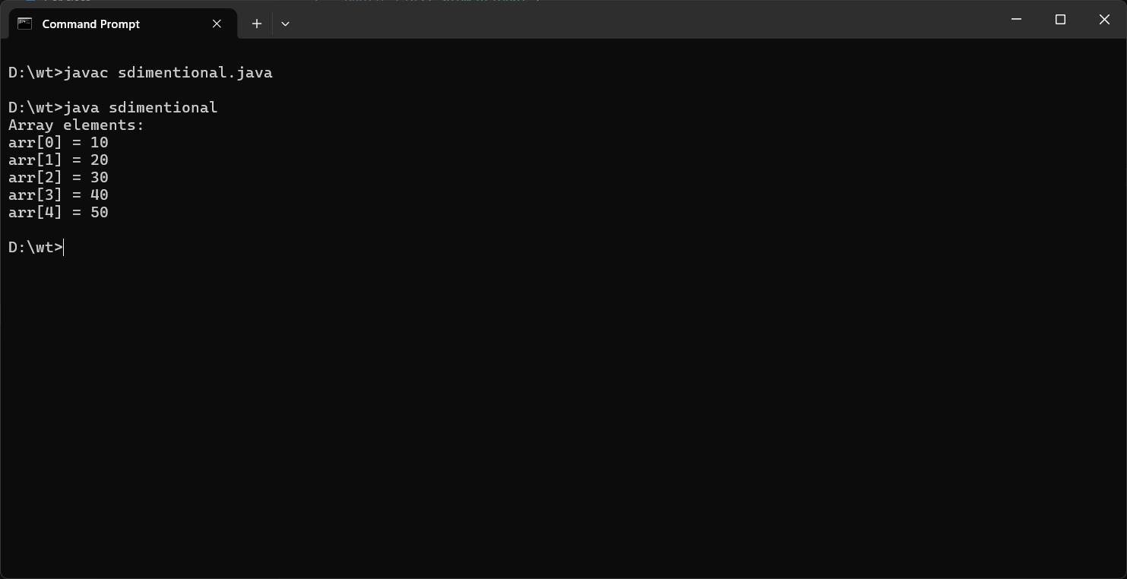
Program No. 15

Objective: Write a program in java to copy the elements from one array to another array.

Code Implementation (Source Code):
public class copy {
public static void main(String[] args) {
int[] src = {1, 2, 3, 4, 5};
int[] dest = new int[src.length];
for (int i = 0; i < src.length; i++) {
dest[i] = src[i];
}
System.out.print("Copied array: ");
for (int x : dest) {
System.out.print(x + " ");
}
}
}

Output Screen:
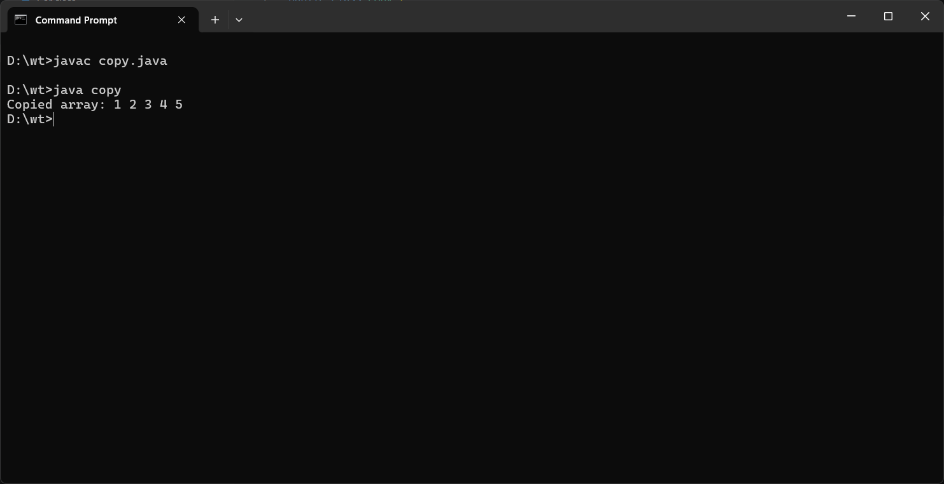
Program No. 16

Objective: Write a program in java to perform the addition and multiplication in 2-D array.

Code Implementation (Source Code):
public class operation {
public static void main(String[] args) {
int[][] a = {{1, 2}, {3, 4}};
int[][] b = {{5, 6}, {7, 8}};
int[][] sum = new int[2][2];
int[][] mul = new int[2][2];

for (int i = 0; i < 2; i++) {
for (int j = 0; j < 2; j++) {
sum[i][j] = a[i][j] + b[i][j];
}
}

for (int i = 0; i < 2; i++) {
for (int j = 0; j < 2; j++) {
for (int k = 0; k < 2; k++) {
mul[i][j] += a[i][k] * b[k][j];
}
}
}

System.out.println("Addition Result:");
for (int[] row : sum) {
for (int val : row) System.out.print(val + " ");
System.out.println();
}
System.out.println("Multiplication Result:");
for (int[] row : mul) {
for (int val : row) System.out.print(val + " ");
System.out.println();
}
}
}

Output Screen:
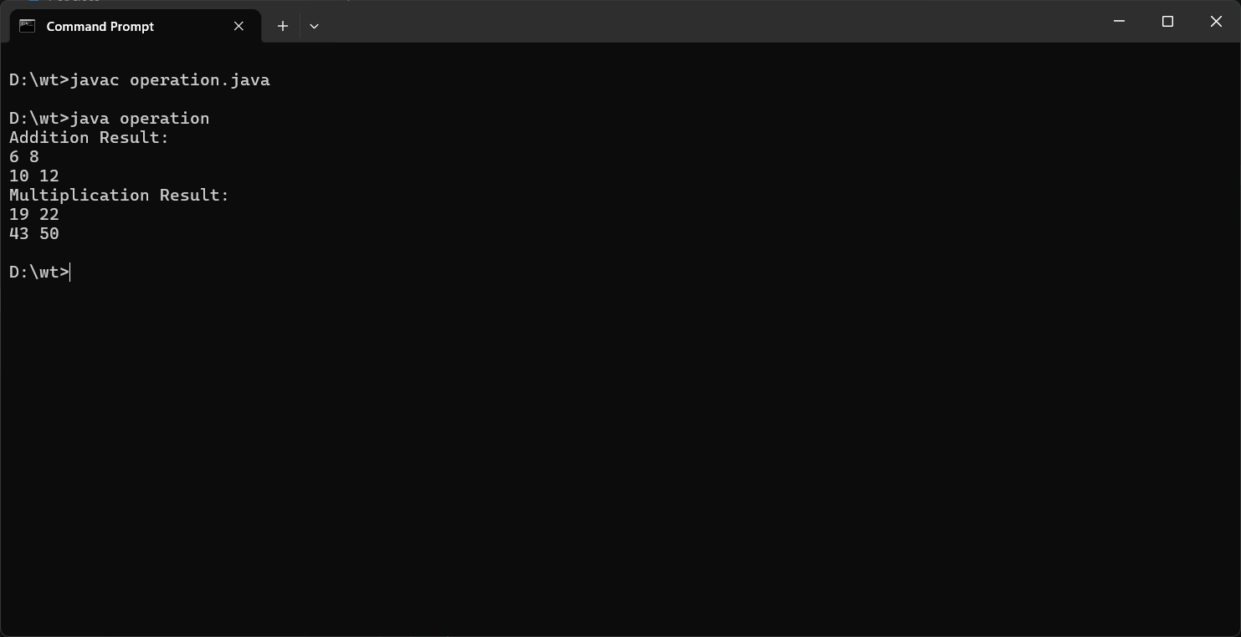
Program No. 17

Objective: Write a program in Java for simple inheritance.

Code Implementation (Source Code):
class Animal {
String name = "Animal";
void eat() {
System.out.println(name + " is eating.");
}
}

class Dog extends Animal {
void bark() {
System.out.println("Dog is barking.");
}
}

public class inheritance {
public static void main(String[] args) {
Dog d = new Dog();
d.name = "Dog";
d.eat();
d.bark();
}
}

Output Screen:
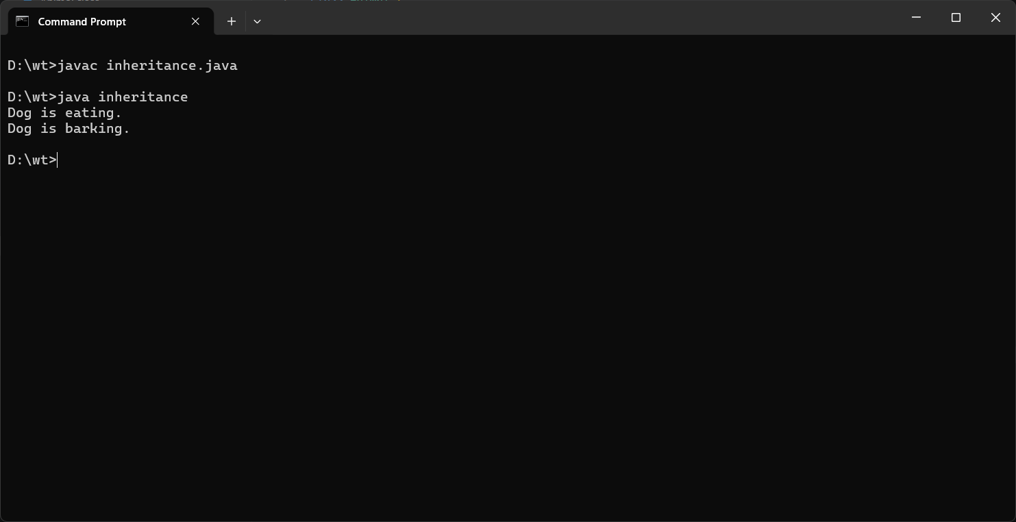

Program No. 18

Objective: Write a program in java for Final keyword.

Code Implementation (Source Code):
public class Final {
final int MAX = 100;

final void display() {
System.out.println("Final method called.");
System.out.println("Final variable MAX = " + MAX);
}

public static void main(String[] args) {
Main obj = new Main();
obj.display();
}
}
Output Screen:
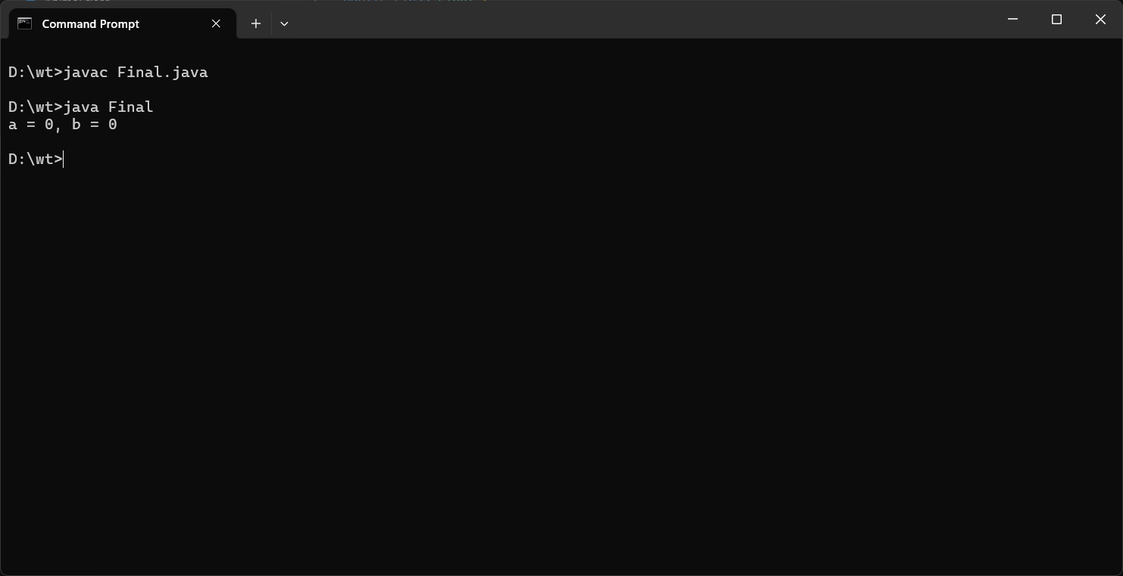
Program No. 19

Objective: Write a program in java for super keyword.

Code Implementation (Source Code):
class Parent {
int x = 10;
void show() {
System.out.println("Parent show()");
}
}

class Child extends Parent {
int x = 20;
void show() {
super.show();
System.out.println("Parent x = " + super.x);
System.out.println("Child x = " + x);
}
}

public class superr {
public static void main(String[] args) {
Child c = new Child();
c.show();
}
}

Output Screen:
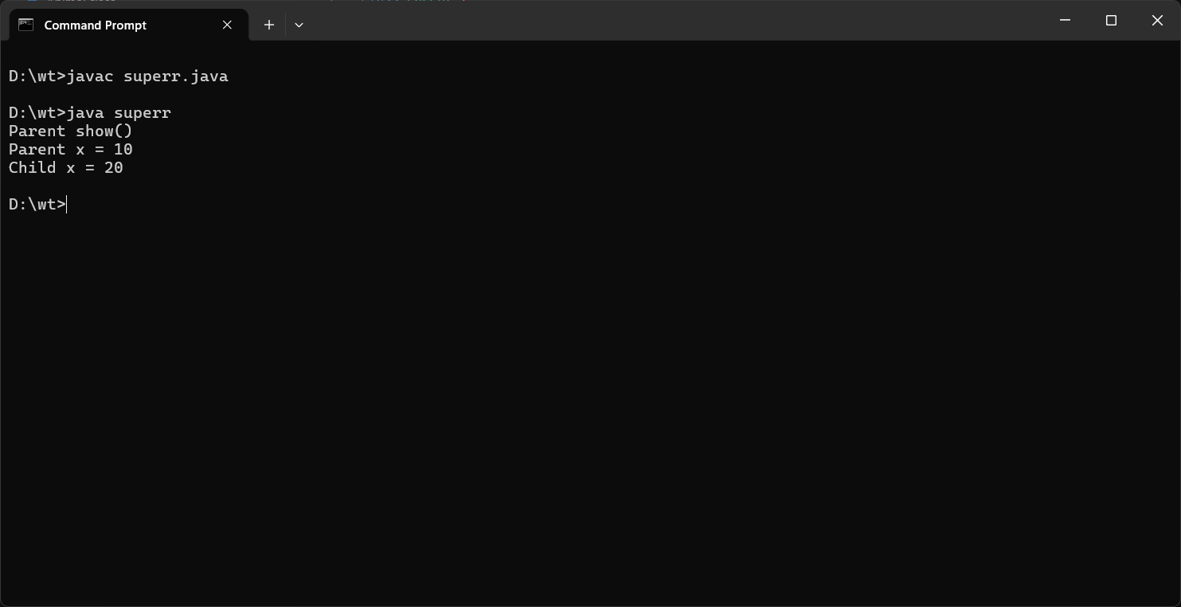

Program No. 20

Objective: Write a program in Java chaining constructor.

Code Implementation (Source Code):
public class abc {
int a, b, c;
abc() {
this(1, 2);
System.out.println("No-arg constructor");
}
abc(int a, int b) {
this(a, b, 0);
System.out.println("Two-arg constructor");
}
abc(int a, int b, int c) {
this.a = a; this.b = b; this.c = c;
System.out.println("Three-arg: a=" + a + " b=" + b + " c=" + c);
}
public static void main(String[] args) {
new abc();
}
}

Output Screen:
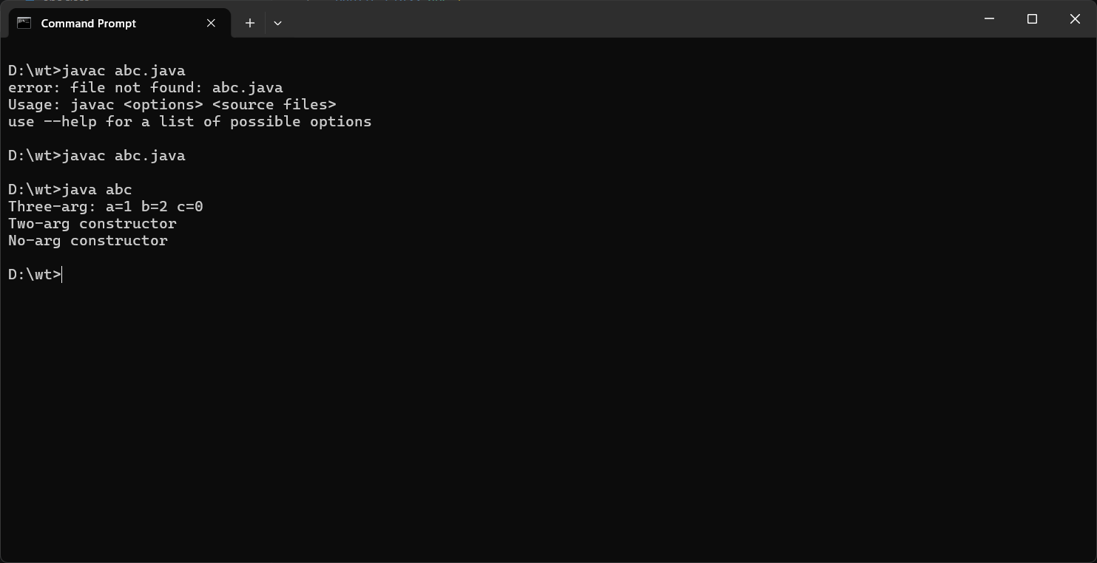

Program No. 21

Objective: Write a program in Java for abstract method and abstract class.

Code Implementation (Source Code):
abstract class Shape {
abstract double area();
void display() {
System.out.println("Area = " + area());
}
}
class Circle extends Shape {
double r;
Circle(double r) { this.r = r; }
double area() { return Math.PI * r * r; }
}
class Rectangle extends Shape {
double l, w;
Rectangle(double l, double w) { this.l = l; this.w = w; }
double area() { return l * w; }
}
public class abstract {
public static void main(String[] args) {
Shape s1 = new Circle(5);
Shape s2 = new Rectangle(4, 6);
s1.display();
s2.display();
}
}

Output Screen:
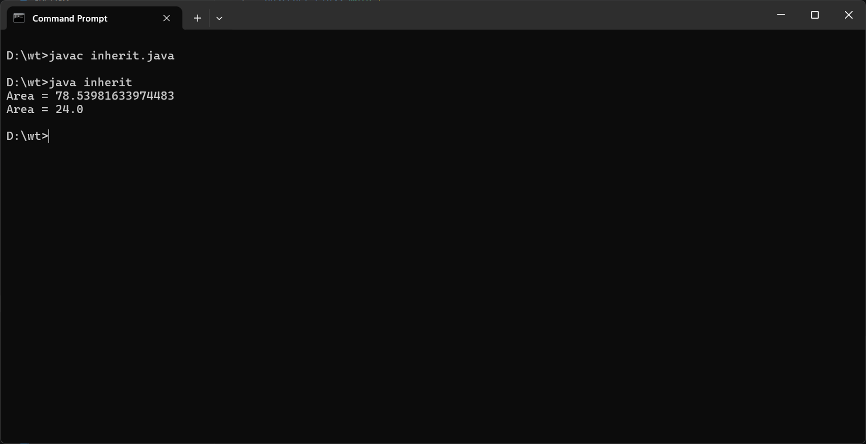

Program No. 22

Objective: Write a program in Java for interface.

Code Implementation (Source Code):
interface Drawable {
void draw();
}

interface Resizable {
void resize(int factor);
}

class Square implements Drawable, Resizable {
int side = 5;
public void draw() {
System.out.println("Drawing Square with side = " + side);
}
public void resize(int factor) {
side *= factor;
System.out.println("Resized side = " + side);
}
}

public class draw {
public static void main(String[] args) {
Square sq = new Square();
sq.draw();
sq.resize(3);
sq.draw();
}
}

Output Screen:
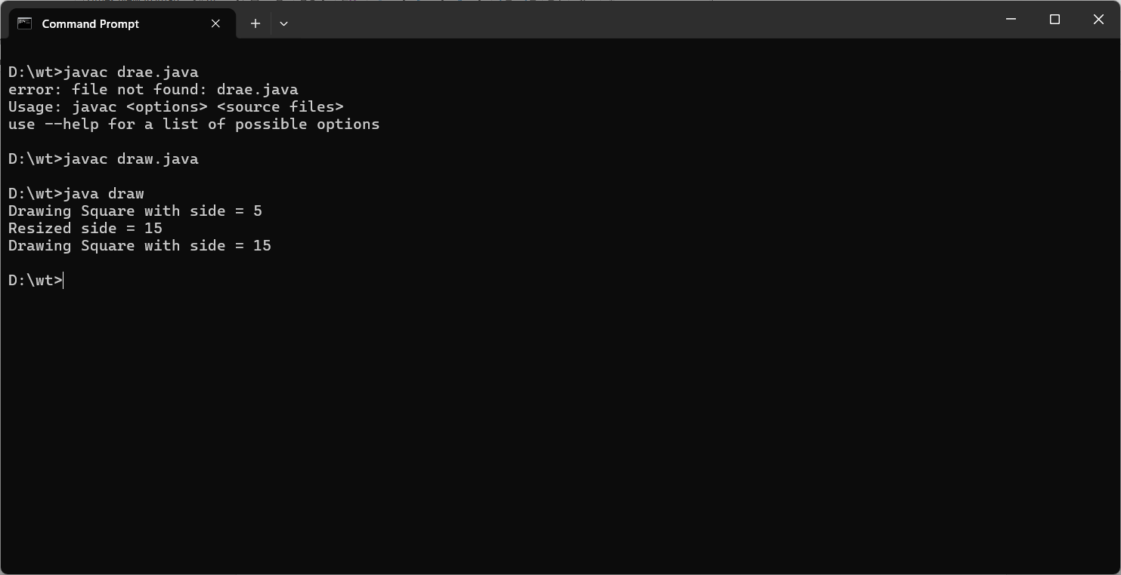

Program No. 23

Objective: Write a program in Java multiple inheritance.

Code Implementation (Source Code):
interface Father {
default void tall() {
System.out.println("Father: Tall");
}
}

interface Mother {
default void intelligent() {
System.out.println("Mother: Intelligent");
}
}

class Child implements Father, Mother {
void myTraits() {
tall();
intelligent();
System.out.println("Child: Both traits inherited");
}
}

public class Minheritance {
public static void main(String[] args) {
Child c = new Child();
c.myTraits();
}
}

Output Screen:
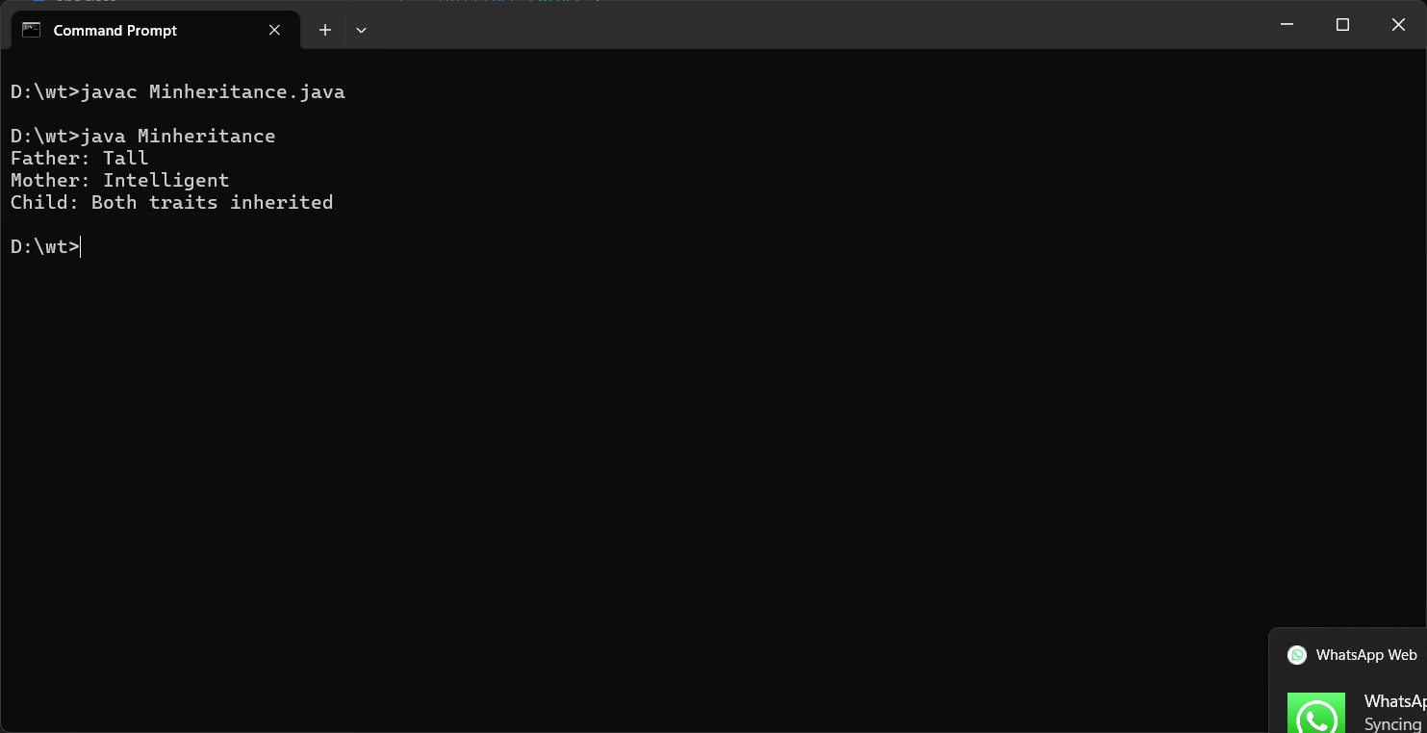

Program No. 24

Objective: Write a program in Java for Object Cloning (shallow and deep copy).

Code Implementation (Source Code):
class Address implements Cloneable {
String city;
Address(String city) { this.city = city; }
protected Object clone() throws CloneNotSupportedException {
return super.clone();
}
}
class Student implements Cloneable {
String name;
Address addr;
Student(String name, Address addr) {
this.name = name; this.addr = addr;
}

protected Object clone() throws CloneNotSupportedException {
return super.clone();
}

Student deepClone() throws CloneNotSupportedException {
Student s = (Student) super.clone();
s.addr = (Address) addr.clone();
return s;
}
}

public class cloning {
public static void main(String[] args) throws CloneNotSupportedException {
Address a = new Address("Delhi");
Student s1 = new Student("Manu", a);
Student s2 = (Student) s1.clone();
Student s3 = s1.deepClone();

s2.addr.city = "Mumbai";
System.out.println("Shallow - s1 city: " + s1.addr.city);
System.out.println("Shallow - s2 city: " + s2.addr.city);

s3.addr.city = "Noida";
System.out.println("Deep - s1 city: " + s1.addr.city);
System.out.println("Deep - s3 city: " + s3.addr.city);
}
}

Output Screen:
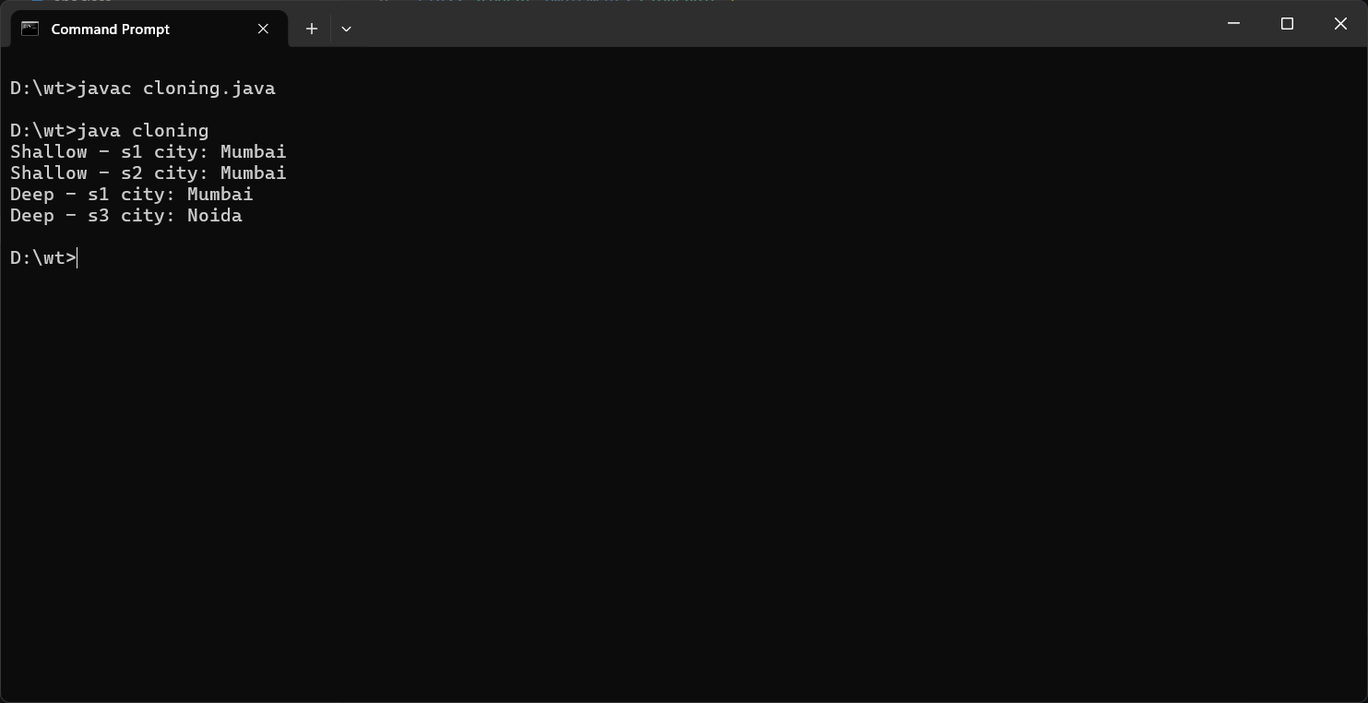
Program No. 25

Objective: Write a program in Java for Inner Classes (all types).

Code Implementation (Source Code):
public class program{
class Inner {
void show() { System.out.println("Regular Inner Class"); }
}
static class StaticNested {
void show() { System.out.println("Static Nested Class"); }
}

void methodWithLocalClass() {
class Local {
void show() { System.out.println("Local Inner Class"); }
}
new Local().show();
}

public static void main(String[] args) {
program outer = new program();
outer.new Inner().show();
new StaticNested().show();

outer.methodWithLocalClass();

Runnable r = new Runnable() {
public void run() { System.out.println("Anonymous Inner Class"); }
};
r.run();
}
}

Output Screen:

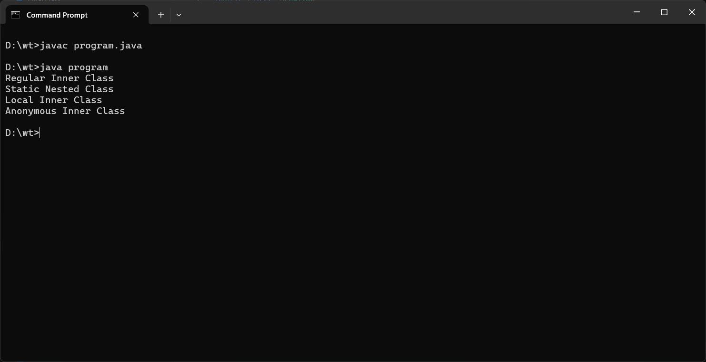

Program No. 26

Objective: Write a program in java to create the package (user defined package).

Code Implementation (Source Code):
package myPackage;
public class Message {
public void show() {
System.out.println("Hello from user defined package *message*!");
}
}

import myPackage.Message;

public class Q26 {
public static void main(String[] args) {
Message msg = new Message();
msg.show();
}
}

Output Screen:

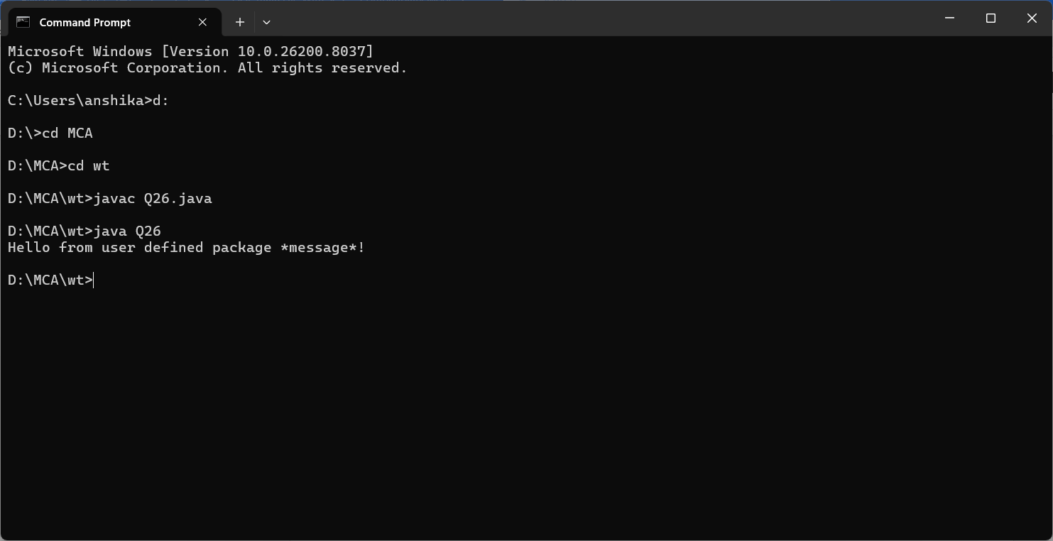
Program No. 27

Objective: Write a program in Java for exception handling by using try, catch and finally.

Code Implementation (Source Code):
public class Q27 {
public static void main(String[] args) {
try {
int a = 10, b = 0;
int result = a / b;
System.out.println("Result = " + result);
} catch (ArithmeticException e) {
System.out.println("Exception caught: " + e.getMessage());
} finally {
System.out.println("Finally block always executes.");
}
}
}

Output Screen:
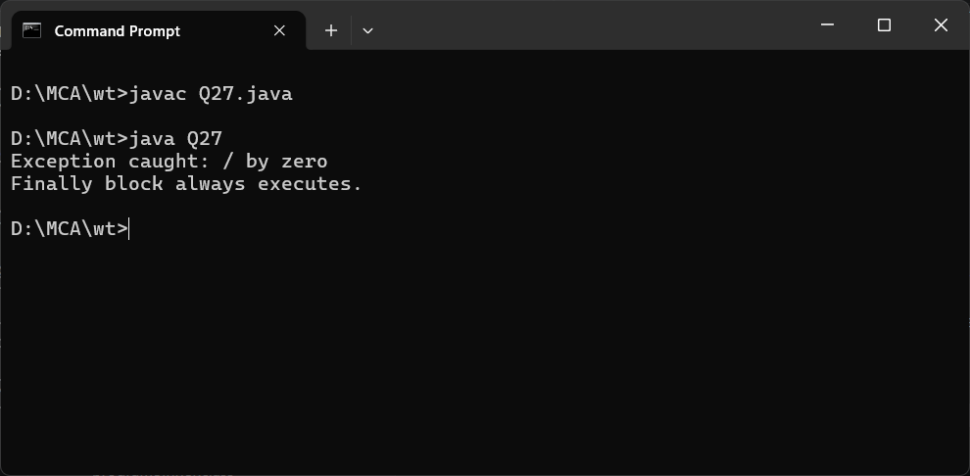
Program No. 28

Objective: Write a program in Java for throw and throws Exception

Code Implementation (Source Code):
import java.util.*;

public class ThrowThrowsDemo {

// Method using 'throws'
static void checkAge(int age) throws Exception {
if (age < 18) {
// using 'throw'
throw new Exception("Not eligible to vote");
} else {
System.out.println("Eligible to vote");
}
}

public static void main(String[] args) {
try {
checkAge(16); // change value to test
} catch (Exception e) {
System.out.println("Exception caught: " + e.getMessage());
}
}
}

Output :
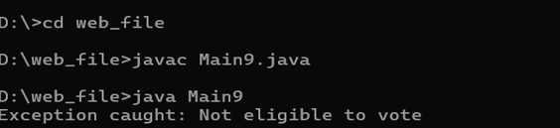

Program No. 29

Objective: Write a program in Java to throw your own Exceptions.

Code Implementation (Source Code):
class InsufficientBalanceException extends Exception {
public InsufficientBalanceException(String message) {
super(message); }}
public class Main10 {
static void withdraw(int balance, int amount) throws InsufficientBalanceException {
if (amount > balance) {
throw new InsufficientBalanceException("Insufficient balance in your account");
} else {
System.out.println("Withdrawal successful! Remaining balance: " + (balance - amount));
}}
public static void main(String[] args) {
try {
withdraw(5000, 7000); // change values to test
} catch (InsufficientBalanceException e) {
System.out.println("Exception caught: " + e.getMessage());
}}}
Output :
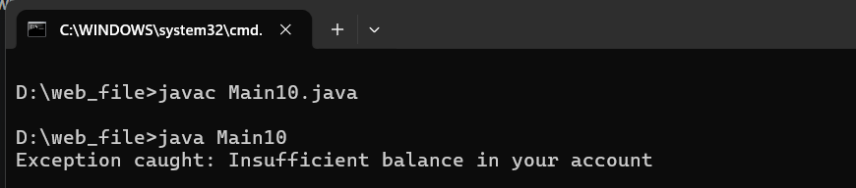

Program No. 30

Objective: Write a program in Java to reading and writing in file using byte stream.

Code Implementation (Source Code):
import java.io.*;
public class ByteStreamDemo {
public static void main(String[] args) {
try {
FileOutputStream fos = new FileOutputStream("sample.txt");
String data = "Hello, this is byte stream example!";
byte[] bytes = data.getBytes();
fos.write(bytes);
fos.close();
System.out.println("Data written to file successfully.");
FileInputStream fis = new FileInputStream("sample.txt");
int i;
System.out.println("Reading data from file:");
while ((i = fis.read()) != -1) {
System.out.print((char) i); }
fis.close();
} catch (IOException e) {
System.out.println("Error: " + e.getMessage());
}}}
Output :
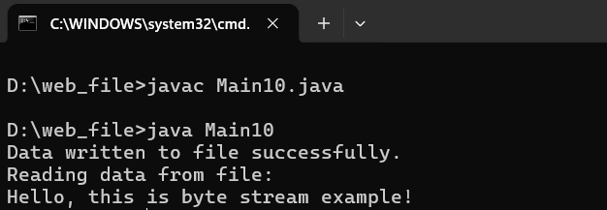
Program No. 31

Objective: Write a program in Java to reading and writing in file using character stream.

Code Implementation (Source Code):
import java.io.*;
public class CharacterStreamDemo {
public static void main(String[] args) {
try {
FileWriter fw = new FileWriter("sample.txt");
String data = "Welcome to Java File Handling using Character Stream!";
fw.write(data);
fw.close();
System.out.println("File written successfully!");
FileReader fr = new FileReader("sample.txt");
int i;
System.out.println("File content is:");
while ((i = fr.read()) != -1) {
System.out.print((char) i);
}
fr.close();
} catch (IOException e) {
System.out.println("Error occurred: " + e.getMessage());
}}}
Output :
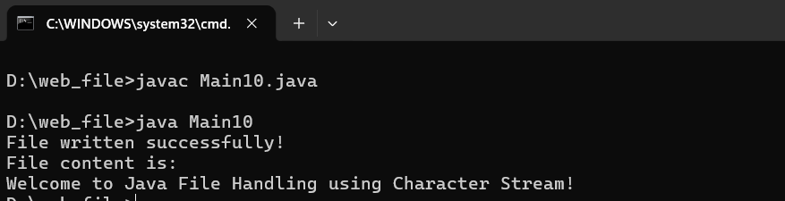

Program No. 32

Objective: Write a program in Java to reading and writing through console class.

Code Implementation (Source Code):
import java.io.*;
public class ConsoleDemo {
public static void main(String[] args) {
Console con = System.console();
if (con == null) {
System.out.println("Console not available");
return;
}
String name = con.readLine("Enter your name: ");
char[] password = con.readPassword("Enter your password: ");
con.printf("Hello %s!\n", name);
con.printf("Your password length is %d characters\n", password.length);
}
}
Output :
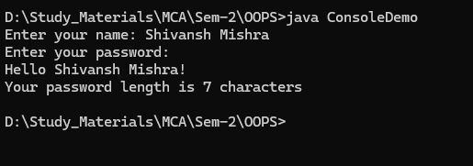

Program No. 33

Objective: Write a program in Java how to create thread using Thread Class.

Code Implementation (Source Code):

class MyThread extends Thread {
public void run() {
for (int i = 1; i <= 5; i++) {
System.out.println("Thread: " + i);
try { Thread.sleep(500); }
catch (InterruptedException e) { System.out.println(e); }
}
}
}

public class Q33 {
public static void main(String[] args) {
MyThread t = new MyThread();
t.start();
for (int i = 1; i <= 5; i++) {
System.out.println("Main: " + i);
}
}
}

Output:

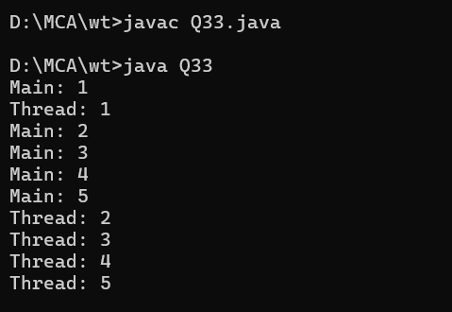

Program No. 34

Objective: Write a program in Java how to create thread using Runnable interface.

Code Implementation (Source Code):

class MyRunnable implements Runnable {
public void run() {
for (int i = 1; i <= 5; i++) {
System.out.println("Runnable Thread: " + i);
try { Thread.sleep(400); }
catch (InterruptedException e) { System.out.println(e); }
}
}
}

public class Q34 {
public static void main(String[] args) {
MyRunnable r = new MyRunnable();
Thread t = new Thread(r);
t.start();
for (int i = 1; i <= 5; i++) {
System.out.println("Main Thread: " + i);
}
}
}

Output:

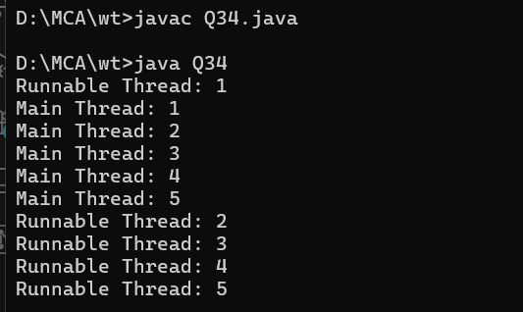

Program No. 35

Objective: Write a program in Java to implement the multithreading.

Code Implementation (Source Code):

class Thread1 extends Thread {
public void run() {
for (int i = 1; i <= 3; i++)
System.out.println("Thread 1 - Count: " + i);
}
}

class Thread2 extends Thread {
public void run() {
for (int i = 1; i <= 3; i++)
System.out.println("Thread 2 - Count: " + i);
}
}

class Thread3 extends Thread {
public void run() {
for (int i = 1; i <= 3; i++)
System.out.println("Thread 3 - Count: " + i);
}
}

public class Q35 {
public static void main(String[] args) {
Thread1 t1 = new Thread1();
Thread2 t2 = new Thread2();
Thread3 t3 = new Thread3();
t1.start();
t2.start();
t3.start();
}
}

Output:

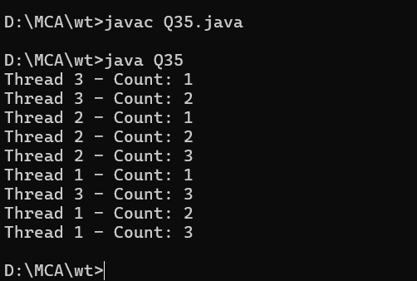
Program No. 36

Objective: Write a program in Java to achieve synchronization in threads.

Code Implementation (Source Code):

class Counter {
private int count = 0;

synchronized void increment() {
count++;
}

int getCount() { return count; }
}

class MyThread extends Thread {
Counter c;
MyThread(Counter c) { this.c = c; }

public void run() {
for (int i = 0; i < 1000; i++)
c.increment();
}
}

public class Q36 {
public static void main(String[] args) throws InterruptedException {
Counter c = new Counter();
MyThread t1 = new MyThread(c);
MyThread t2 = new MyThread(c);
t1.start(); t2.start();
t1.join(); t2.join();
System.out.println("Final Count: " + c.getCount());
}
}

Output:

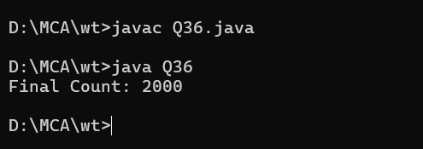

Program No. 37

Objective: Write a program in Java to implement the concept of Priorities in threads.

Code Implementation (Source Code):

class PriorityThread extends Thread {
PriorityThread(String name) {
super(name);
}

public void run() {
System.out.println(getName() + " priority: " + getPriority() + " running.");
}
}

public class Q37 {
public static void main(String[] args) {
PriorityThread t1 = new PriorityThread("Low Priority");
PriorityThread t2 = new PriorityThread("Normal Priority");
PriorityThread t3 = new PriorityThread("High Priority");

t1.setPriority(Thread.MIN_PRIORITY); // 1
t2.setPriority(Thread.NORM_PRIORITY); // 5
t3.setPriority(Thread.MAX_PRIORITY); // 10

t1.start(); t2.start(); t3.start();
}
}

Output:

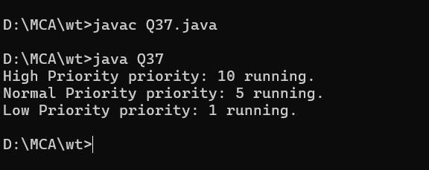

Program No. 38

Objective: Write a program in Java to illustrate the concept of Generic Programming.

Code Implementation (Source Code):

class GenericBox<T> {
private T value;

GenericBox(T value) { this.value = value; }

T getValue() { return value; }

void display() {
System.out.println("Value: " + value + " | Type: " + value.getClass().getName());
}
}

class GenericPair<K, V> {
K key; V val;
GenericPair(K key, V val) { this.key = key; this.val = val; }
void display() { System.out.println("Key: " + key + ", Value: " + val); }
}

public class Q38 {
static <T extends Comparable<T>> T findMax(T a, T b) {
return (a.compareTo(b) > 0) ? a : b;
}

public static void main(String[] args) {
GenericBox<Integer> intBox = new GenericBox<>(42);
GenericBox<String> strBox = new GenericBox<>("Java");
intBox.display();
strBox.display();

GenericPair<String, Integer> pair = new GenericPair<>("Roll No", 31);
pair.display();

System.out.println("Max(10, 20): " + findMax(10, 20));
System.out.println("Max(Apple, Mango): " + findMax("Apple", "Mango"));
}
}

Output:

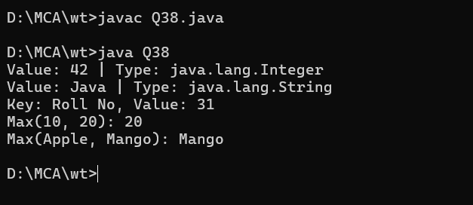

Program No. 39

Objective: Write a program in Java to illustrate the concept of event handling (using various event handlers).

Code Implementation (Source Code):

import java.awt.*;
import java.awt.event.*;

public class Q39 extends Frame implements ActionListener, MouseListener, KeyListener {

Label label;
Button btn;
TextField tf;

Q39() {
setLayout(new FlowLayout());
label = new Label("Event Handling Demo");
btn = new Button("Click Me");
tf = new TextField(20);

btn.addActionListener(this);
addMouseListener(this);
tf.addKeyListener(this);

add(label); add(btn); add(tf);
setSize(400, 200);
setTitle("Event Handling");
setVisible(true);

addWindowListener(new WindowAdapter() {
public void windowClosing(WindowEvent e) { dispose(); }
});
}

public void actionPerformed(ActionEvent e) {
label.setText("Button Clicked!");
}

public void mouseClicked(MouseEvent e) {
label.setText("Mouse Clicked at (" + e.getX() + "," + e.getY() + ")");
}

public void mouseEntered(MouseEvent e) {}
public void mouseExited(MouseEvent e) {}
public void mousePressed(MouseEvent e) {}
public void mouseReleased(MouseEvent e) {}

public void keyTyped(KeyEvent e) {
label.setText("Key Typed: " + e.getKeyChar());
}

public void keyPressed(KeyEvent e) {}
public void keyReleased(KeyEvent e) {}

public static void main(String[] args) {
new Q39();
}
}

Output:

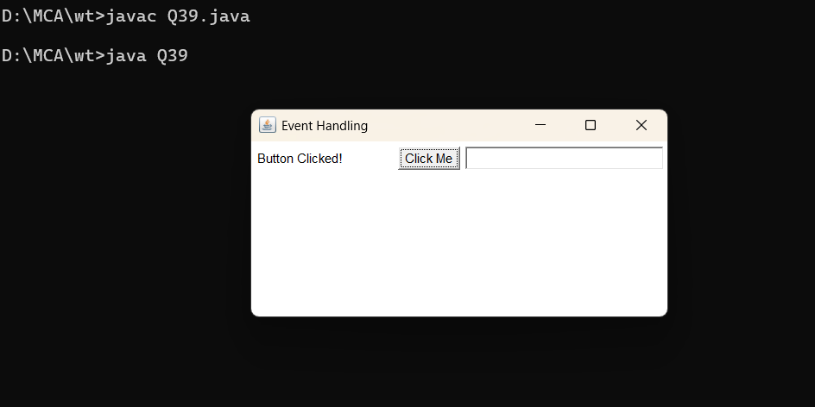
Program No. 40

Objective: Create a simple student registration application using various swing components (like: JFrame, JButton, JLabel, text fields, text areas, check box and radio buttons).

Code Implementation (Source Code):

import javax.swing.*;
import java.awt.*;
import java.awt.event.*;

public class Q40 extends JFrame implements ActionListener {

JLabel nameLabel, rollLabel, genderLabel, courseLabel, addressLabel;
JTextField nameField, rollField;
JRadioButton male, female;
ButtonGroup genderGroup;
JCheckBox java, python, cpp;
JTextArea addressArea;
JButton submit, clear;
JTextArea output;

Q40() {
setTitle("Student Registration Form");
setSize(500, 600);
setLayout(new GridLayout(0, 2, 5, 5));
setDefaultCloseOperation(JFrame.EXIT_ON_CLOSE);

nameLabel = new JLabel("Name:");
nameField = new JTextField();
rollLabel = new JLabel("Roll No:");
rollField = new JTextField();
genderLabel = new JLabel("Gender:");
male = new JRadioButton("Male");
female = new JRadioButton("Female");
genderGroup = new ButtonGroup();
genderGroup.add(male); genderGroup.add(female);
JPanel genderPanel = new JPanel();
genderPanel.add(male); genderPanel.add(female);
courseLabel = new JLabel("Courses:");
java = new JCheckBox("Java");
python = new JCheckBox("Python");
cpp = new JCheckBox("C++");
JPanel coursePanel = new JPanel();
coursePanel.add(java); coursePanel.add(python); coursePanel.add(cpp);
addressLabel = new JLabel("Address:");
addressArea = new JTextArea(3, 20);
submit = new JButton("Submit");
clear = new JButton("Clear");
output = new JTextArea(5, 30);
output.setEditable(false);

submit.addActionListener(this);
clear.addActionListener(this);

add(nameLabel); add(nameField);
add(rollLabel); add(rollField);
add(genderLabel); add(genderPanel);
add(courseLabel); add(coursePanel);
add(addressLabel); add(new JScrollPane(addressArea));
add(submit); add(clear);
add(new JLabel("Output:")); add(new JScrollPane(output));

setVisible(true);
}

public void actionPerformed(ActionEvent e) {
if (e.getSource() == submit) {
String gender = male.isSelected() ? "Male" : female.isSelected() ? "Female" : "Not selected";
String courses = (java.isSelected() ? "Java " : "") +
(python.isSelected() ? "Python " : "") +
(cpp.isSelected() ? "C++ " : "");
output.setText("Name: " + nameField.getText() + "\n" +
"Roll No: " + rollField.getText() + "\n" +
"Gender: " + gender + "\n" +
"Courses: " + courses + "\n" +
"Address: " + addressArea.getText());
} else {
nameField.setText(""); rollField.setText("");
genderGroup.clearSelection();
java.setSelected(false); python.setSelected(false); cpp.setSelected(false);
addressArea.setText(""); output.setText("");
}
}

public static void main(String[] args) {
new Q40();
}
}

Output:

